Journal of Production, Operations and Systems Management
e-ISSN: 1984-2430
Editor-in-chief: Paula de Camargo Fiorini

Open Access

Received: / / Approved: / /

TITLE (UP TO 22 WORDS)

TITLE IN PORTUGUESE (UP TO 22 WORDS)

THE MANUSCRIPT MUST NOT CONTAIN ANY INFORMATION ABOUT THE AUTHORS OF THE PAPER

ABSTRACT

Purpose: The aim of this study is to examine...
Theoretical framework: The... Methodology/Approach: The... Findings: The results...
Research, practical & social implications: The study...
Originality/ Value: The value of study...

Keywords:

RESUMO

Objetivo: O objetivo deste estudo é...
Referencial Teórico: O... Metodologia/Abordagem: O... Resultados: Os resultados...
Contribuições, implicações práticas e sociais: o estudo...
Originalidade/Valor: O valor do estudo...

Palavras-chave:

1. INTRODUCTION
The article must necessarily be divided between the sections present in this template. For the writing and presentation of the text, its adequacy to the norms of the American Psychological Association (APA) is required.
Indirect citation out of parentheses, example: According Ali, Almagtome & Hameedi (2019), the....
The text must be written in Times New Roman font, size 12, single spaced and justified. In paragraphs, the special indentation of the first line is 1.25 cm and there is no spacing between them. The page layout must be made on A4 paper (29.7×21 cm), with margins: top (3 cm), left (3 cm), bottom (2 cm) and right (2 cm). The manuscript must be up to 10,000 words, including tables, notes and references.

2. LITERATURE REVIEW
Title of article sections should be written in capital letters. It is not allowed to include a subtitle immediately after a title or a subtitle, at least one paragraph separating them is required.

2.1 Subtitle
Charts, tables, graphs and illustrations must be included in the main document, in the sequence in which they appear in the text and written in the same font as the text (figures must be inserted in the text, preferably in JPEG or PNG). Bolds should only be used in titles and subtitles. Foreign words must be written in italics, while neologisms or unusual meanings are enclosed in “quotes”. Notes should be avoided, when used they should explain or clarify, in a succinct manner, and not be confused with reference to the source; should come at the end of the text, with sequential numbering in Arabic numerals.
The article must be written correctly in grammatical terms, problems of this nature will lead to the rejection of the text by the editor.

2.2 Presentation of tables and figures
The APA presents only two modalities for the presentation of illustrations: tables and figures.

Anything that is not considered a table will be considered a figure. Examples: drawings, schemes, flowcharts, photographs, graphs, maps, organizational charts, plans, tables, portraits, images, among others.
Tables and figures must be prepared according to the order presented in the text and must be inserted as close as possible to the information to which they refer.

Tables: The title of the tables should be succinct and explanatory. Its presentation should be in the upper left corner, with the initial capital letter "T" accompanied by the number that designates it (Table 1, Table 2, Table 3, etc.). Tables are presented sequentially with Arabic numerals.
The font of the title of the table must be the same used in the text, in bold and with spacing of 1.5 cm. Indicate the source when the table is extracted from another work (do not indicate if it is from the author). Example:

Table 1
Cronbach’s Alpha and KMO

Test | Value
Alpha de Cronbach | 0,900
KMO | 0,872
*<0,001

Figures: The identification of the figures must appear in the upper art, preceded by the word "Figure" and the number in Arabic numerals in the text sequence (Figure 1, Figure 2, Figure 3, etc) and the corresponding title.
Indicate the source when the figure is taken from another work (do not indicate if the figure is the author's own). Example:

Figure 1
Flowchart information library diagram.
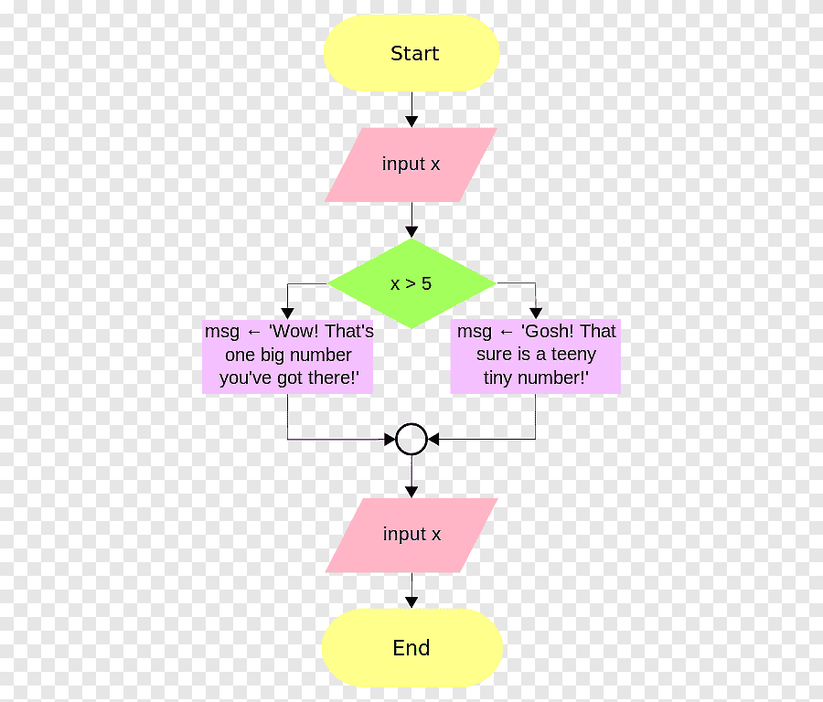
Source: Adapted from XXX (YEAR).

3. METHODOLOGY
Present the methodology used in the study, as well as the research techniques
used.

4. RESULTS AND DISCUSSION
The analysis and discussion of the results should characterize the context of the research, either through the description of the environment, conjuncture or economic sector. Present the development of the research. Structuring subsections in the sense of “responding” to the objectives to which the work proposes. It can be structured in subsections in order to respond to the objectives to which the work proposes.

5. CONCLUSION
Present the main conclusions, limitations of the research and recommendations for future studies).

REFERENCES (References must be presented in alphabetical order. It is extremely important to include the DOI.)

The APA considers that the sources cited in the scientific work must be:

- Listed at the end of the work in alphabetical order by the author's last name (lowercase), followed by the initial letters of the first names and the date in parentheses.;
- Offset in the second row of 1.25 cm from the second row and alignment to the
left;
- For multiple works by the same author, list entries in chronological order,
oldest to newest;
- Regardless of the physical support (book, journal article, slide, DVD, electronic documents, etc.), present the cited works;
- For emphasis in the title or subtitle of publications and periodicals, always use

italics.

References generally consist of four elements: author, date, title and source. Example journal title indication:

Philips, S.D., Blustein, d.L., Jobin-Davis, K., & White, S.F. (2002). Preparation for the school-to-work transition: the views of hight school students. Journal of Vocational Behavior, 61 (2), 202-216. https://doi.org/10.26668/2022.

