APPLICATION OF THE ANALYTICAL HIERARCHY PROCESS IN SUSTAINABILITY IN COMPLEX PROJECTS

Josivan Leite Alves¹, Universidade Federal do Cariri-UFCA
Jeniffer de Nadae¹, Universidade Federal do Cariri-UFCA

Abstract
The depletion of natural resources by civil construction causes significant harm to the environment, requiring sustainable project management that is confirms with the complexity of the task. Thus, sustainability indicators are necessary to regulate the functioning of the constructions about to the environmental, societal and economic measures, applied in the decision making of the project, production and management of the workplace. Therefore, this paper aims to analyze how complexity influences the implementation of sustainability in complex civil construction projects, grounded on the proposition of indicators based on the literature and practical work using the Analytic Hierarchy Process (AHP) method. In terms of the complexity of the projects, the research participants pointed out that changes made over time and the financial aspects are variables that considerably hinder the completion of the building. Finally, it was possible to notice that there is a close relationship between the indicators of complexity and sustainability, where the target audience of the research showed a strong tendency to consider the most important economic aspects of the design and execution of civil construction projects.
Keywords: Sustainability. Construction. Complexity. AHP.

1. Introduction
Even affected by the global financial crises, several countries have invested in urban infrastructure projects to accommodate demand and population growth as an assurance of the quality of life (SACCHI HOMRICH et al., 2017). Nevertheless, the procedure of planning, designing, constructing, and doing construction projects is complex since most buildings are exclusive structures designed for certain roles, budgets, physical conditions, and schedule restrictions (SINOPOLI, 2010). Its complexity has significant impacts on various facets of the terminations, be they in the duration, cost, or tone of delivery (XIA; CHAN, 2012). Also, the project's unique characteristics underpin the purpose of appropriate managerial actions to complete a tackily of civil construction projects require an exceptional level of management and that the application of conventional systems developed for common projects is considered inadequate in complex projects (BACCARINI, 1996).
The accelerated depletion of natural resources by civil construction, the continuous damage to the natural environment, and the significant contributions to the global generation of waste (SWARUP et al., 2011) justify the integration of adequate management combined with objectives and schemes that encourage sustainability. Civil engineering projects are fundamental in determining the quality of life and contribute to the identity and cultural heritage. The sector still has large participation in the countries' economy and promotes the development of the regions by generating jobs and income for the communities. However, it consumes natural resources extensively, in addition to contributing, on a large scale, to changes in the natural environment (ISO 21929-1, 2011).
Thus, sustainable project management is the planning, monitoring, and control of the project delivery and support processes, considering the environmental, economic, and social aspects of the resource life cycle (SILVIUS et al., 2016). Thus, sustainability is not an attack, it is a long-term social and multidimensional goal. In the sustainable development conception, both environmental protection and social-technical innovations are equally fundamental to mitigate anthropic impacts on ecosystems on a micro and macro scale (ROSSI, 2019). That is, the strategies for sustainable development is to maintain the balance between these three dimensions, being defined as an environmentally responsible, socially just, economically viable goal and actions (ELKINGTON, 1994). It is through proper project management that sustainable goals are achieved in an organization and achieving sustainability principles in project management requires a change in culture, education, control, and support from superiors (PMI, 2017).
For that, sustainability indicators are necessary to determine the performance of buildings concerning environmental, social, and economic requirements at regional, national, and/or global scales (SINOPOLI, 2010). In civil construction, they are necessary both for making project, production, and project management decisions, as well as for indicating the public and customers or the economic, environmental, or social impact (ISO 21929-1, 2011).
Sustainability can also be a process that measures the degree or level of quality of the complex system of interaction between the environment and the human being to assess its distance from the sustainable. This assessment is made with quantitative properties (which are the sustainability indicators and indices), and these, in turn, can identify which aspects - environmental, social or economic - if the system does not reach the desired sustainable level - are responsible and which should be repositioned or corrected (FEIL; SCHREIBER, 2017).
Furthermore, indicators are tools that synthesize an amount of information in an appropriate number, with parameters for analysis and decision making, exponential conditions and deficient trends or need for intervention, translating abstract concepts, and with a high degree of measurement (COSTA, 2003). A sustainability indicator can be understood as a quantitative or qualitative tool, which calculates and informs the progress towards the sustainable use and management of economic, social and environmental resources while analyzing changes (LIMA; BARROS, 2008).
Bearing in mind that the complexity inherent to engineering projects hinders or maximizes the effort to implement sustainability, indicators of information complexity of the efforts required for the sustainable use of the project are necessary. Furthermore, the appropriate use of indicators of complexity associated with sustainability, theoretical, and practical experimentation contributes to promoting the practice of planning and executing sustainable works.
Erdogan, Šaparauskas, and Turskis (2019) state that the civil construction sector is a complex industry that has a lasting impact on the economy, the environment, and society, in addition to the fact that it involves too many investments. Thus, management and construction technology are two critical factors that influence the industry. That is, the poor execution of construction projects, taking into account costs and planning, hinder the implementation of sustainable practices (ERDOGAN; APARAUSKAS; TURSKIS, 2019).
Therefore, this paper aims to analyze how complexity influences the implementation of sustainability in complex civil construction projects, grounded on the proposition of indicators based on the literature and practical work using the Analytic Hierarchy Process (AHP) method. Also, this study seeks to answer the following questions: (#Q1) Based on studies on sustainability certifications, presented in the Theoretical Background, what are the recurring indicators in your assessments? (#Q2) What indicators of complexity can be applied in the context of civil construction? (#Q3) What is the perception of the interviewees about the influence that the complexity of the projects has on the practical applications of the fundamentals of sustainability? (#Q4) What dimension or trend of indicators do the study participants have?
Thus, the sampling for collection will be limited to engineering professionals working in the Metropolitan Region of Cariri, extreme south of Ceará, more specifically in the CRAJUBAR Triangle, formed by the municipalities of Crato, Juazeiro do Norte and Barbalha. This research contributes to the national literature by combining mathematical tools with practical applications. It encourages managers and academics to develop indicators for building a sustainability classification system for complex projects, according to their specificities. It also explains how the AHP determines the weights for each criterion, proposing a conceptual sustainability index module.

2. Theoretical Background
2.1 Concepts and Definitions
Sustainable development is a multidimensional concept, which emphasizes integration and searches a dynamic balance between the economic, social, and environmental aspects of a region, to ensure intergenerational and intra-generational equity (KWATRA et al., 2020). This concept was introduced by Elkington (1994) in which he emphasizes that the balance of these three dimensions, must be maintained, known as the Triple Bottom Line (TBL) of sustainability.
The Brundtland Report exposes the concept of sustainable development as "one that meets the needs of the present without compromising the ability of future generations to meet their own needs" (BRUNDTLAND et al., 1987, p. 46). This definition emphasizes the aspect of future guidance as a basic element of sustainability and this care for the future implies an intelligent use of natural resources and other conceptions related to the environmental aspect (SILVIUS; SCHIPPER; PLANKO, 2012).
From the TBL perspective, the social sustainability refers to poverty reduction; The economic one refers to the long-term sustainability of renewable and non-renewable resources so that they feed the production system and provide long-term economic benefits; and environmental sustainability refers to the preservation and maintenance of existing forms of life on the planet (KWATRA et al., 2020).
The economic dimension is constituted not only by the formal economy but also by informal activities that generate services for individuals and groups, thereby increasing the monetary income and the standard of living of individuals; the social dimension consists of aspects related to the qualities of human beings, such as their skills, dedication, and experiences, addressing both the internal and external environment of the company; finally, the environmental dimension involves the fundamentals of environmental science (including ecology, habitat diversity and forests), air and water quality (protecting human health through the reduction of chemical contamination and pollution), in addition to encompassing conservation and management of renewable and non-renewable resources (DE OLIVEIRA CLARO; CLARO; AMÂNCIO, 2008).
Applied to the development of the project, sustainability involves efficient resource allocation, minimum energy consumption, low energy intensity incorporated in construction materials, reuse and recycling, and other mechanisms to achieve effective and efficient use in the short and long term of natural resources (DING, 2008).
However, the continuing demands for speed in construction cost control, and quality and safety in the workplace, along with technological advances, economic globalization, environmental issues, and fragmentation of the construction industry have resulted in a rapid and spiraling increase in the complexity of construction processes construction (GIDADO, 1996). The complexity of a project is defined as a measure of the difficulty of implementing a planned production workflow about one or more quantifiable management objectives. An efficient implementation of management functions (from planning to control) can influence the effect of the project's complexity on its success (GIDADO, 1996).
It is worth mentioning that the objective of sustainable engineering projects is to guarantee the integration of the natural and artificial environment, without compromising the functionality of the engineering system or the ecosystem and society, and this harmony between natural and built environments must be maintained at the local scales, regional and global (GAJJAR et al., 2015).
Thus, for the evaluation of environmental projects, it is necessary to develop a model to facilitate the multidimensional evaluation of criteria that assist in decision making. In this sense, the evaluation of the project can be considered a continuous process, which occurs during the initial stages of development. Regardless of the size of the construction, there are always many possibilities during the decision-making process that must be evaluated and judged (DING, 2008). When analyzing sustainability, an indicator that is multidimensional and that takes into account the environmental (by the maintenance of natural ecosystems), economic (profitable activity), and social (fair and equitable distribution of the wealth generated) dimensions (GÓMEZ-LIMÓN; SANCHEZ-FERNANDEZ, 2010).
The correct use and interpretation of indicators allow the strengthening of decisions, facilitating, among other dynamics, the participation of society in decision-making and sustainable strategies (MINISTÉRIO DO MEIO AMBIENTE, 2019). Also, the adoption of sustainable practices and preparation of studies like these, expose the importance of assessing sustainability in the management of complex projects, adding to the literature an approach on how to proceed through the measurement challenges to achieve sustainable development.
For Gibberd (2003), indicators must be displayed with a clear perception of the context in which they are located, they must be linked to clearly defined objectives and the selection or development of indicators must be designed to measure the speed of change or progress in the sense to achieve goals and objectives. Besides, ensuring that the relationship between sustainable development and the created environment is explicit and intelligible, including an understanding of how the created environment can be used following sustainable development. This includes a process of prioritizing aspects of sustainable development and ensuring that these are reflected in the performance targets selected for performance (AULICINO, 2008). Indicators act as useful tools to bring the necessary objectivity in measuring and understanding sustainable development and must consider at least three basic dimensions of sustainability when assessing progress (KWATRA et al., 2020).
Eid (2009) analyzed the integration of sustainable development in the management of construction projects and concluded that: project management is an efficient vehicle to introduce a more accurate change, not only for the practice of the construction industry; Project management processes and knowledge fall short of committing to a sustainable approach; Mapping sustainable development in project management processes and areas of knowledge, identifies several opportunities for the introduction of sustainability guidelines in all project management processes (EID, 2009).
Some characteristics of the project provide a basis for determining the appropriate managerial actions to complete a project. Complexity is one of these critical dimensions since it requires an exceptional level of management and the application of conventional systems developed for common projects is considered inadequate for complex projects (BACCARINI, 1996).
Thus, the complexity of the project can be defined as the property that makes it difficult to understand, predict and control its general behavior, even when reasonably complete information about the system is provided (VIDAL; MARLE, 2008). Baccarini (1996) proposes that the complexity of the project be defined as "consisting of many varied interrelated parts" and can be operationalized in terms of differentiation and interdependence. This definition can be applied to any project dimension relevant to the project management process, such as organization, technology, environment, information, decision making, and systems. It is worth emphasizing that complexity is a concept distinctly different from two other characteristics of the project - size and uncertainty (BACCARINI, 1996).

2.2 Sustainability Indicators in Complex Projects
Aulicino (2008) listed five methodologies for assessing sustainability in civil construction, they are: Building Research Establishment Environmental Assessment Method - BREEAM; Sustainable Building Assessment Tool - SBAT (South Africa); Sustainable Building Tool - SBTool (International); Category 01 of the High Environmental Quality method - AQUA adapted to Brazil from the French method: NF batiments terciaires HQE; and Leadership in Energy and Environmental Design - LEED-ND (USA).
Another tool that has a list of indicators is ISO 21929-1: 2011, which establishes a main set of indicators to be considered when using and developing sustainability indicators to assess the sustainability performance of new or existing buildings. Thus, Table 1 shows the most frequent indicators considered by ISO 21929-1 in comparison with the evaluation methodologies listed by Aulicino (2008).

Table 1: Sustainability Indicators
Indicadores | BREEAM | SBAT | SBTool | AQUA | LEED | ISO 21929-1
Use of natural resources | X | X |  | X | X | X
Construction costs | X |  | X | X | X | X
Adaptation of the local community |  | X | X |  |  | X
Efficient use of water | X | X |  | X | X | X
Consumption of materials | X | X |  | X | X | X
Users' health and well-being | X | X | X | X | X | X
Use of the soil | X | X | X |  |  | X
Efficient use of energy | X | X | X | X | X | X
Use of local labor |  | X | X | X | X | X
Sources: Authors (2020).

In Table 1, the indicators represent at least one dimension of sustainability presented in the TBL defined by Elkington (1994). In the environmental dimension, there is the use of natural resources, efficient use of water and use of the soil; economy: construction costs, material consumption and efficient use of energy; finally, in social: adaptation of the local community, health and well-being of users and use of local labor. Even with this grouping by dimension, the indicators are not exclusive to them, and the others can also be referred to.
In terms of project complexity, Carvalho, Patah and Bido (2015) presented indicators and variables to classify complex projects, under which they are presented in Table 2.

Table 2: Complexity indicators for project management
Complexity indicators | Variables
Financial | Associated with the financial volume of the project, the percentage value of the estimated risks, the project's sales, margin, and the percentage of investment in research and development or engineering for the project.
Contractual | Contractual position of the company in the project, the number of external partners contractually associated, internal partners of the company, and degree of relationship with the client.
Technical complexity | Clarity of product definition or project scope; and Need for new technological development.
Organizational considerations | Project type (supply, system or turnkey), contractual complexity, the strategic importance of the project for the company, and Strategic relevance for the client.
Sources: Carvalho et al. (2015, p. 7).

Cooke-Davies et al. (2011), suggest that complexity in civil construction projects be analyzed based on four indicators listed in Table 3.

Table 3: Indicators of complexity in civil construction projects
Complexity indicators | Variables
Structural | High levels of interconnectivity and codependency between activities or organizational complicity, resulting in unclear or redundant means of communication and approval.
Technological | Technical challenges and extreme projects or for which no solution is displayed within the time available.
Organizational | Objectives and goals not defined and not shared; secret or conflicting goals; cultural barriers, language and communication barriers; secret agendas.
Temporal | Unstable and unpredictable environment over time; uncontrollable changes in scope; uncertain political, regulatory, and technical environments during the project life cycle.
Source: Adapted from Cooke-Davies et al. (2011, p. 17).

Finally, Ortiz et al. (2009) suggest replacing the raw materials with products with a less environmental burden and supporting the application of renewable energy technologies throughout the life cycle of an enterprise. They also exemplify the phases involved in the life cycle of a construction, which includes raw materials, construction, use and maintenance, and final disposal or demolition. Construction materials involve processes such as production, use, and final disposal, as shown in Figure 1.
Figure 1: Construction life cycle
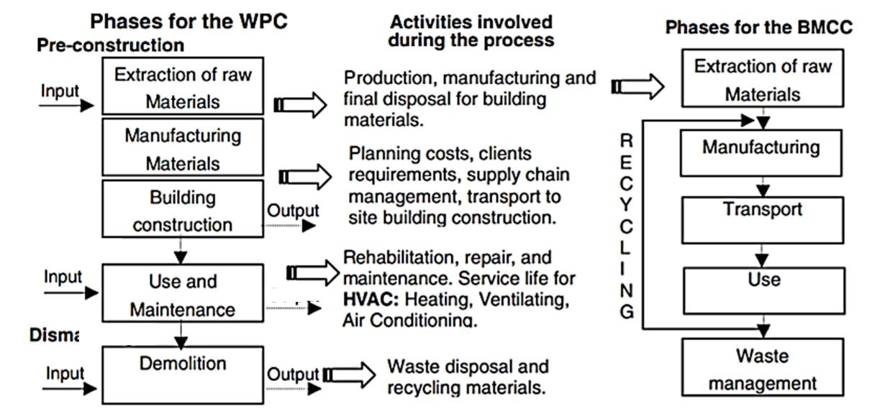
Source: Ortiz et al. (2009, p. 11).
Note: Whole process of the construction (WPC); Building material and component combinations (BMCC).

Thus, there is a need to apply indicators in sustainable projects throughout the life cycle of the works, in such a way that they point out the best solutions from a sustainable point of view depending on the complexity of the project as a whole (DING, 2008).

3. Methodological Procedures
3.1 Object of Study
To goal attainment of this study, the Analytic Hierarchy Process-AHP method was applied. Initially, the objective, methodology, and problem questions were defined. For the composition of the Theoretical Background, we sought authors who contributed to the topic in question and who listed, clearly and objectively, indicators of sustainability and complexity in projects. Thus, it was noticed that several international certifications assess the degree of sustainability of the projects. In her thesis, Aulicino (2008) listed such certifications under which, together with ISO 21929-1, they served as a basis for the selection of sustainability indicators for this research. For the indicators of complexity in projects, the ones listed by Carvalho et al. (2015) and Cooke-Davies et al. (2011).
That is, the selection of indicators used in this study derives from section 2 (Theoretical Background) since the authors and concepts presented in this section are those that contribute significantly to the theme and integrate the issues related to sustainability, the complexity of projects and civil construction actions. Table 4 shows the problem questions of this research, showing the procedure and its respective methods. Thus, a sample literature review was carried out to identify the indicators.

Table 4: Problem research questions
# | Problem issues | Procedure | Method
1 | Based on studies on sustainability certifications, presented in the Theoretical Background, what are the recurring indicators in your assessments? | Identification of studies about the theme. | Simple literature review.
2 | What indicators of complexity can be applied in the context of civil construction? | Identification of studies about the theme. | Simple literature review.
3 | What is the perception of the interviewees about the influence that the complexity of the projects has on the practical applications of the fundamentals of sustainability? | Application of mathematical tool | Interview and application of AHP.
4 | What dimension or trend of indicators do the study participants have? | Application of mathematical tool | Interview and application of AHP.
Sources: Authors (2020).

It is worth noting that the AHP model used together with the Saaty scale assesses importance among the elements (WEGNER et al., 2018). The professionals participating in the research would have to have an employment bond and have participated in some large public or private civil construction in the target cities. The interview was involved with only one person responsible for the company or activity. The professionals' judgments were made regarding the relevance of one indicator compared to another, being made subjectively and transformed into a numerical value using a scale from 1 to 9, with the value 1 meaning equal importance and 9 extreme importance (LAI et al., 1999). The other values ​​for peer review are shown in Table 5.

Table 5: Numerical Saaty Scale
Scale | Definition
1 | Equally important
3 | Moderate importance
5 | More important
7 | Very important
9 | Extreme importance
2,4,6,8 | Intermediate values
Soucer: Saaty (2005).

3.2 Data Collection Procedures
After the literature review, a questionnaire was created under which it was reviewed and validated for further data collection that had occurred in December 2019, among construction professionals in the cities of Crato, Juazeiro do Norte, and Barbalha. In total, 9 companies operating at the regional level were contacted, according to the knowledge of the authors and disclosure of their activities in the media. A response rate of 60% (rounding up) was obtained, in which each company provided a person responsible for participating in the study.
Data collection was performed in person. The participants evaluated the indicators in pairs and answered some subjective questions. According to the Secretariat of Cities (2020), Cariri will become a metropolitan region due to the second most expressive urban region in Ceará, given the conurbation studied by the municipalities of Crato, Juazeiro do Norte and Barbalha, called CRAJUBAR.

3.3 Data Analysis Procedures
The matrix [A] for the application of the AHP method, according to Saaty (1991), is defined by equation (1), as well as its elements. It is noticed that the main diagonal of the matrix will always be 1 and it should also be noted the reciprocity of the elements according to the main diagonal.

α_{ij} > 0 | [A]= | 1 | α₁₂ | ... | α_{1n}
α_{ij}= 1 :. α_{ji}= 1 |  | 1/α₂₁ | 1 | ... | α_{2n} | (1)
α_{ij}= 1/ α_{ji} |  | .  .  . | .  .  . | ... | .  .  .
α_{ik}= α_{ij} * α_{jk} |  | 1/α_{n1} | 1/α_{n2} | ... | 1

To calculate the main value of Eigen (ʎMax), the columns of the standardized matrix [A] must be added and divide each element of the columns by their respective sum. The Saaty Consistency-CI index (2005) is defined by equation (2), where n is the number of criteria evaluated.
$CI= \frac{ʎMax-1}{n-1}$ (2)

The author also proposed to verify if the CI is adequate. For this, the ratio between the CI value and the random consistency index IR is determined (Table 6), and the matrix will be considered as consistent if this ratio is less than 10%, as shown in equation (3).

$CR=\frac{CI}{RI}<0,1 \sim 10\%$ (3)

Table 6: Random Consistency Indexes
n | 1 | 2 | 3 | 4 | 5 | 6 | 7 | 8 | 9 | 10
RI | 0 | 0 | 0,52 | 0,89 | 1,11 | 1,25 | 1,35 | 1,40 | 1,45 | 1,49
Soucer: Saaty (2005).

The indicators considered in the studies are those presented in the Theoretical Background. The indicators of sustainability are shown in Table 1, according to the certifications exposed by Aulicino (2008). For indicators of complexity was considered the Tables 2 and 3. Participants were asked to assess the influence of each sustainability indicator on the construction or companies for which they are responsible. Also, they were asked to have a perception of how each complexity indicator influences sustainability when carrying out the peer review. Finally, the mean, a measure of the centrality of a data set, and the standard deviation, a measure of dispersion that informs the uniformity of the data, were calculated. The formulas for these measures are shown in Table 7.

Table 7: Average and standard deviation
Average | $\overline{X}$=$\frac{\sum{Xn}}{n}$
Standard deviation | σ =$\sqrt{\sum_{i=1}^{n}{\frac{(Xi-\overline{X})²}{n-1}}}$
Sources: Authors (2020).

4. Results
There was only a return of 5 participants from different companies under which they will be identified only by letters of the alphabet. They analyzed the elements in each column of the matrix that were compared in pairs about the element in the top row. These judgments used to fill the comparison matrices were derived from the opinions of professionals, with at least a degree in some area of ​​civil construction or other specialties of Civil Engineering, who still have an employment relationship during the period of realization of this research and that operate in the Cariri Metropolitan Region, more specifically in the CRAJUBAR triangle.
First, it was questioned which of the dimensions of the TBL of sustainability the participants took more into account in the execution and mainly in the planning of the works. Respondent “A” reported that the environmental and social aspects because his builds have a considerable environmental impact and that positively interferes with several communities in the region, as they are in the area of ​​water resources. Respondents “B”, “C” and “D”, in which the first and the last work in the planning of works and the middle in the execution, informed, undoubtedly, that the economic dimension is the most important for the constructions, mainly buildings. The “D” exemplified that it takes the social dimension into account when planning fire-fighting projects. The “E” explained that the environmental dimension is also considered as it involves asphalt paving works, but that the economic one is the most recurrent since it creates solutions with a greater economic return.
In terms of the complexity of the projects, they mentioned out that changes made over time and the financial aspects are variables that considerably hinder the completion of the construction. The “A” reported that: “any change in the project influences the sustainable aspects for the execution of the work, sometimes making construction unfeasible according to the project”. The "E" added: "especially in the financial sphere, as most of them are harmful both in terms of the changes themselves and due to the time lost".
Concerning the application of the AHP method, the final priorities of the indicators are highly dependent on the weights assigned by the participants. That is, small changes in the relative weights can, therefore, cause major changes in the final classification. Thus, Figure 2 shows the result of applying the method, in percentage, of the 5 participants. The values ​​obtained in each process of applying the AHP method were rounded to two decimal places.

Figure 2: Sustainability indicators
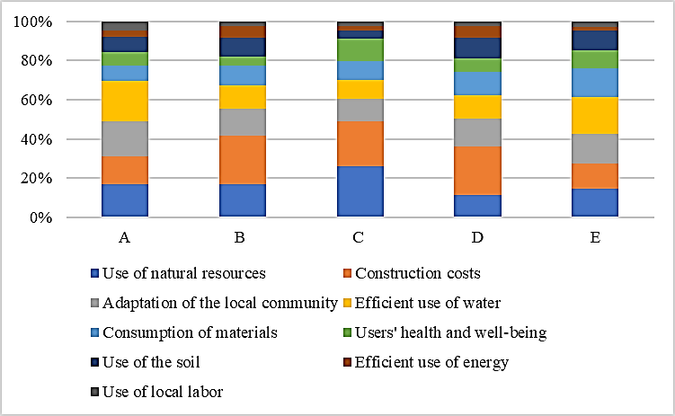
Sources: Authors (2020).

Respondents “B”, “C” and “D” attributed higher values ​​to the construction costs indicator, totaling a preference of 25%, 23%, and 24%, respectively, with “A” and “B” being second in the use of natural resources. "A" and "E" consider water consumption to be the most relevant indicator, 20%, and 19% respectively. In the second position, "A" has adaptation from the local community and "E" ties (15%) in indicators of the use of natural resources, the adaptation of the local community, and the consumption of materials. The indicators with the lowest weights are the use of local labor and efficient use of energy. The acceptable, but not excluding, consistency index (CI) is 0,1 and all matrices reached or are equal to this value, as shown in Figure 2.
Regarding the influence of complexity factors in promoting sustainability, Figure 3 shows the group's results. The CI of each matrix is ​​also shown, with values ​​around 0,1.

Figure 3: Complexity indicators
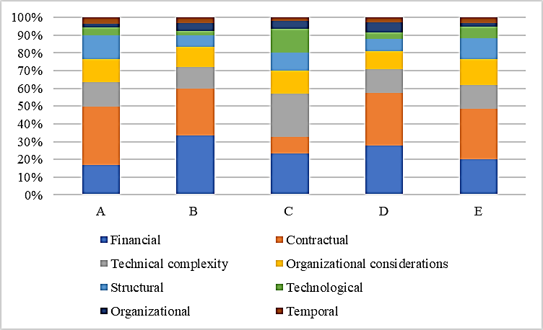
Sources: Authors (2020).

Except for the participant “C”, which showed a greater preference for the technical complexity indicator, the respondents showed a considerable tendency for the financial and contractual indicators. Those with the lowest values ​​are those related to organizational and temporal issues.
Also, the values ​​attributed by the group are based on subjective judgments, in which the consistency of each matrix was calculated. By increasing or decreasing the weight of individual criteria, changes resulting from priorities, and the classification of indicators can be observed. As the classification does not have a high sensitivity, values ​​so far from 0.1, it was not necessary to review the assigned values. Thus, Figure 4 shows the consistency index of the two matrices of each participant.

Figure 4: Matrix consistency index
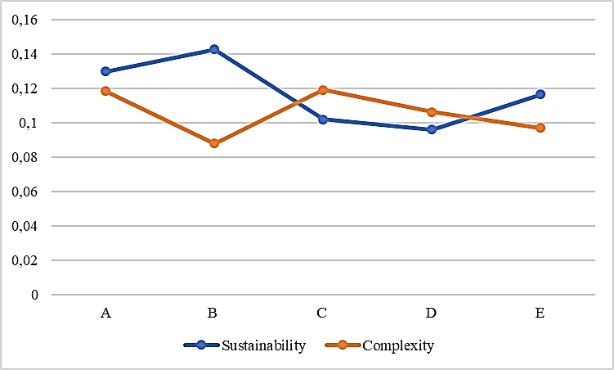
Sources: Authors (2020).

5. Discussions

The answers were more consistent in the matrices of the complexity indicators (with = $\overline{X}$=0,10 and σ= 0,012), while those of sustainability were less consistent (with $\overline{X}$=0,12 e σ= 0,017). There was a correlation between the responses of the group, which made it possible to calculate the average ($\overline{X}$) of the assignments in each indicator. The calculation of the standard deviation (σ) reported a small dispersion of the average value, as shown in Table 8.

Table 8: Sample dispersion measures
Sustainability Ind. | $$\overline{X}$$ | σ | Complexity Ind. | $$\overline{X}$$ | σ
Use of natural resources | 0,17 | 0,054 | Financial | 0,24 | 0,065
Construction costs | 0,20 | 0,056 | Contractual | 0,25 | 0,093
Adaptation of the local community | 0,15 | 0,022 | Technical complexity | 0,15 | 0,051
Efficient use of water | 0,14 | 0,047 | Organizational considerations | 0,12 | 0,018
Consumption of materials | 0,11 | 0,025 | Structural | 0,09 | 0,029
Users' health and well-being | 0,08 | 0,024 | Technological | 0,06 | 0,042
Use of the soil | 0,08 | 0,025 | Organizational | 0,04 | 0,016
Efficient use of energy | 0,04 | 0,019 | Temporal | 0,03 | 0,006
Use of local labor | 0,03 | 0,009
Sources: Authors (2020).

From that information, it was possible to verify the trend of the studied group, that is, which sustainability and complexity indicators had greater attributions. Figure 5 shows the group's trend about sustainability indicators. The more external to the graph the element is, the greater the assignment given by the group.

Figure 5: Group sustainability indicators
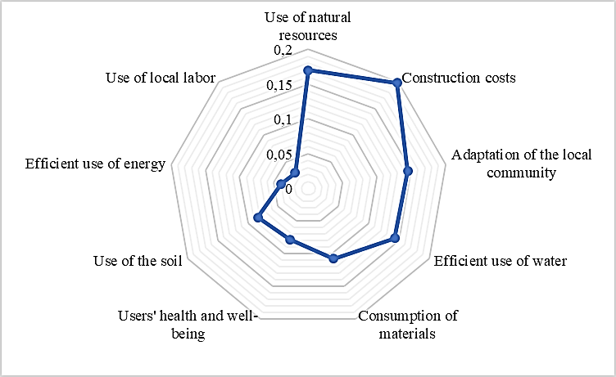
Sources: Authors (2020).

It is observed that the participants considered construction costs as the most relevant indicator in engineering constructions. This trend can be justified by the fact that such professionals are hired to develop technical solutions for adapting or altering the environment for any human need, in a way that guarantees the lowest possible cost and meets the regulatory requirements for safety and durability. However, it is noted that there is a concern about the use of natural resources since their extraction causes environmental damage and changes the lifestyle of the resident community.
Other research regarding the application of AHP in sustainability in civil construction projects has obtained similar results. The study by El-kholy and Akal (2019) found that economic performance, opportunity cost, material cost, and energy cost were the indicators with the highest weights among 19 economic criteria to assess the sustainability of highway infrastructure projects. Water and energy consumption were also recurrent indicators.
Waris et al. (2019), after the application of the AHP, concluded that the focus of sustainability in the Malaysian construction industry is directed towards the selection of materials, the structural design, and the recycling of materials. As such, there is a gap between the evaluation of the conventional equipment selection approach and the inclusion of the sustainable concept in decision-making during the purchasing phase of a project.
According to the analysis by Yildiz, Kivrak, and Arslan (2019), after the application of the AHP, 20% of the weights were attributed to economic sustainability, 45% to environmental, and 35% to social sustainability. The highlighted indicators were: transport and accessibility, quality of the built environment, conservation of resources, commercial and economic opportunities, conservation of resources, support for social life, historical and cultural values.
Moura et al. (2013) mention that in the Region of Cariri there is a large production of solid waste from the extraction and processing of Pedra Cariri, an ornamental rock used mainly by the ceramic industry in the region. The author also mentions that the Cariri stone slabs are square in commercial dimensions and that there is still no survey of the volume generated from these residues, due to the variation in the exploration processes. But it is proven that the residues cause silting up of the rivers, changes in the natural landscape, and compromises some road access roads of the local community, which may or may not justify the greater attribution of the indicators shown in Figure 5. The trends for the complexity indicators are shown in Figure 6.

Figure 6: Group complexity indicators
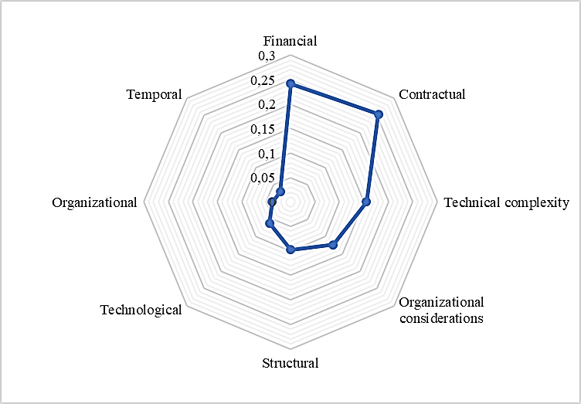
Sources: Authors (2020).

It is noticed that the greatest weights are in the contractual (25%) and financial (24%) indicators, followed by technical complexity (15%). This fact shows a strong correlation between sustainability indicators and those of complexity since in both matrices there was a greater tendency for the economic base. As these are professionals who work in companies that participate in public works, it is evident that they have a greater concern in such indicators so that they can gain an advantage in bidding. And as O Cariri is under development, there is a lot of investment by the public sector in urban infrastructure works.
According to the Ministry of Economy (2020), the investment applied in the works started in 2019 in the city of Crato was 2.15 million reais, in Juazeiro do Norte it was 3.35 million and in Barbalha 861.60 million. Such values ​​are higher in 2018. In other words, companies and professionals tend to adapt to win public tenders so that they can remain in the caririense market, because of the fall in private sector investment in civil construction.

6. Conclusions
This research sought to understand how complexity influences the implementation of sustainability in complex civil construction projects, based on the proposition of indicators based on literature and practical study using the AHP method. This work was also successful in answering the following questions: (#Q1) Based on studies on sustainability certifications, presented in the Theoretical Background, what are the recurring indicators in your assessments? (#Q2) What indicators of complexity can be applied in the context of civil construction? (#Q3) What is the perception of the interviewees about the influence that the complexity of the projects has on the practical applications of the fundamentals of sustainability? (#Q4) What dimension or trend of indicators do the study participants have? For this, a questionnaire for peer review was created and applied to construction professionals working in the cities of Carto, Juazeiro do Norte, or Barbalha.
Through the composition of the theoretical background of this research, it was possible to answer the questions (#Q1) and (#Q2), in which 9 sustainability and 8 complexity indicators were listed for civil construction projects. And so, a questionnaire was created and applied to work professionals, under which they evaluated the indicators in pairs.
Thus, it was possible to notice that there is a close relationship between the indicators of complexity and sustainability, where the target audience of the research showed a strong tendency to consider the most important economic aspects of the design and execution of civil construction projects, thus responding to (#Q4). They also showed considerable concern about environmental indicators, especially those that indicated the use of raw materials. Another important aspect is that both the literature on the subject and the practical experience of this study exposed that the adequate management of resources enables greater success in the implementation of sustainable practices in complex projects.
Besides, considering that the indicators with the greatest weight in the group were financial and contractual, it is understood that sustainable practices depend not only on individual initiatives but also on government incentives, especially on contractual requirements in public works and evaluation of the life cycle, thus enabling the understanding of (#Q4).
Finally, the results presented here are limited to the region studied and the group participating in the research, which prevents generalization in other contexts. Another factor to consider is that this study obtained a response rate of 60% of the companies identified. As a suggestion for future work, a Systematic Literature Review associated with bibliometric parameters is carried out, so that a greater number of indicators can be listed and, consequently, the application of AHP nationwide.

References
AULICINO, P. Análise de métodos de avaliação de sustentabilidade do ambiente construído: o caso dos conjuntos habitacionais., 28. nov. 2008. São Paulo: Universidade de São Paulo. Disponível em: <http://www.teses.usp.br/teses/disponiveis/3/3146/tde-09022009-185405/>.

BACCARINI, D. The concept of project complexity—a review. International Journal of Project Management, v. 14, n. 4, p. 201–204, 1996. Disponível em: <https://linkinghub.elsevier.com/retrieve/pii/0263786395000933>.

BRUNDTLAND et. al. Our common future—Call for action. 1987. Environmental Conservation, 14(4), 291-294.

CARVALHO, M. M. DE; PATAH, L. A.; DE SOUZA BIDO, D. Project management and its effects on project success: Cross-country and cross-industry comparisons. International Journal of Project Management, v. 33, n. 7, p. 1509–1522, 2015. Disponível em: <https://linkinghub.elsevier.com/retrieve/pii/S0263786315000733>.

COSTA, Marcela da Silva. Mobilidade urbana sustentável: um estudo comparativo e as bases de um sistema de gestão para Brasil e Portugal. EESC/USP. São Paulo, 2003.

DE OLIVEIRA CLARO, Priscila Borin; CLARO, Danny Pimentel; AMÂNCIO, Robson. Entendendo o conceito de sustentabilidade nas organizações. Revista de Administração-RAUSP, v. 43, n. 4, p. 289-300, 2008.

DING, G. K. C. Sustainable construction—The role of environmental assessment tools. Journal of Environmental Management, v. 86, n. 3, p. 451–464, 2008. Disponível em: <https://linkinghub.elsevier.com/retrieve/pii/S0301479706004270>. .

ELKINGTON, J. Towards the Sustainable Corporation: Win-Win-Win Business Strategies for Sustainable Development. California Management Review, v. 36, n. 2, p. 90–100, 1994.

EL-KHOLY, Amr M.; AKAL, Ahmed Y.. Proposed Sustainability Composite Index of Highway Infrastructure Projects and Its Practical Implications. Arabian Journal For Science And Engineering, [s.l.], v. 45, n. 5, p. 3635-3655, 31 out. 2019. Springer Science and Business Media LLC. http://dx.doi.org/10.1007/s13369-019-04201-1.

EID, Mohamed El Mohamady. Sustainable development & project management: rethinking relationships in the construction industry: integrating sustainable development (SD) into project management (PM) processes. LAP Lambert Academic Pub., 2009.

ERDOGAN, Seyit Ali; ŀAPARAUSKAS, Jonas; TURSKIS, Zenonas. A Multi-Criteria Decision-Making Model to Choose the Best Option for Sustainable Construction Management. Sustainability, [s.l.], v. 11, n. 8, p. 2239, 14 abr. 2019. MDPI AG. http://dx.doi.org/10.3390/su11082239.

FEIL, Alexandre André; SCHREIBER, Dusan. Sustentabilidade e desenvolvimento sustentável: desvendando as sobreposições e alcances de seus significados. Cadernos EBAPE. BR, v. 15, n. 3, p. 667-681, 2017.

GAJJAR, K. H.; SHAH, M. V.; SHAH, A. J. Sustainability In Geotechnical Engineering. , , n. ii, p. 328–335, 2015.

GIBBERD, J. No Integrating Sustainable Development into Briefing and Design Processes of Buildings in Developing Countries: An Assessment Tool, 2003. University of Pretoria.

GIDADO, K. I. Project complexity: The focal point of construction production planning. Construction Management and Economics, v. 14, n. 3, p. 213–225, 1996.

GÓMEZ-LIMÓN, J.A.; SANCHEZ-FERNANDEZ, G. Empirical evaluation of agricultural sustainability using composite indicators. Ecological Economics, 2010. Disponível em: http://www.sciencedirect.com/science/article/pii/S0921800909004765. Acesso em: 30 jul. 2019.

ISO 21929-1. INTERNATIONAL STANDARD Sustainability in building construction — Sustainability indicators —. , v. 2011, 2011.

KWATRA, S.; KUMAR, A.; SHARMA, P. A critical review of studies related to construction and computation of Sustainable Development Indices. Ecological Indicators, v. 112, p. 106061, 2020. Disponível em: <https://linkinghub.elsevier.com/retrieve/pii/S1470160X1931057X>.

LAI, V. S.; TRUEBLOOD, R. P.; WONG, B. K. Software selection: a case study of the application of the analytical hierarchical process to the selection of a multimedia authoring system. Information & Management, v. 36, n. 4, p. 221–232, 1999. Disponível em: <https://linkinghub.elsevier.com/retrieve/pii/S037872069900021X>.

MINISTÉRIO DA ECONOMIA. No Title. Disponível em: <http://transferenciasabertas.planejamento.gov.br/QvAJAXZfc/opendoc.htm?document=painelcidadao.qvw&lang=en-US&host=QVS%40srvbsaiasprd01&anonymous=true>. Acesso em: 20/1/2020.

MINISTÉRIO DO MEIO AMBIENTE. Indicadores. 2019. Disponível em: <http://www.mma.gov.br/cidades-sustentaveis/planejamento-ambiental-urbano/item/8055.html>. Acesso em: 29 nov. 2019.

MOURA, W. A.; LEITE, M. B.; BASTOS, A. J. O. Avaliação do uso de resíduo de serragem de pedra Cariri (RSPC) para produção de concretos convencionais. Ambiente Construído, v. 13, n. 1, p. 07–24, 2013.

ORTIZ, O.; CASTELLS, F.; SONNEMANN, G. Sustainability in the construction industry: A review of recent developments based on LCA. Construction and Building Materials, v. 23, n. 1, p. 28–39, 2009. Disponível em: <https://linkinghub.elsevier.com/retrieve/pii/S0950061807003005>.

PMI. The Bottom Line on Sustainability. 2011. Disponível em: <https://www.pmi.org/-/media/pmi/documents/public/pdf/white-papers/the-bottom-line-on-sustanability.pdf>. Acesso em: 30 nov. 2019.

ROSSI, Emilio et al. Sustainable 3D Printing: Design Opportunities and Research Perspectives. In: International Conference on Applied Human Factors and Ergonomics. Springer, Cham, 2019. p. 3-15.

SAATY, T. L. Analytic Hierarchy Process. Encyclopedia of Biostatistics, 2005. Chichester, UK: John Wiley & Sons, Ltd. Disponível em: <http://doi.wiley.com/10.1002/0470011815.b2a4a002>.

SACCHI HOMRICH, A.; SAUT, A. M.; ALVES FREIRE, A. P.; et al. Management of large complex multi-stakeholders projects: a bibliometric approach. Revista Gestão da Produção Operações e Sistemas, v. 12, n. 2, p. 261–282, 2017.

SECRETARIA DAS CIDADES. No Title. Disponível em: <https://www.cidades.ce.gov.br/regiao-metropolitana-do-cariri/>. Acesso em: 20/1/2020.

SILVIUS, A. J. G.; UTRECHT, S.; SCHIPPER, R. P. J.; AETSVELD, V.; MANAGEMENT, C. Sustainability in project management : A literature review and impact analysis Delivered by Ingenta to : Guest User Delivered by Ingenta to : Guest User. Social Busniess, v. 4, n. 1, p. 63–96, 2016.

SILVIUS, Gilbert; SCHIPPER, R. O. N.; PLANKO, Julia. Sustainability in project management. Gower Publishing, Ltd., 2012.

SINOPOLI, J. Energy and Sustainability. Smart Building Systems for Architects, Owners and Builders. p.189–200, 2010. Elsevier. Disponível em: <https://linkinghub.elsevier.com/retrieve/pii/B978185617653800017X>.

SWARUP, L.; KORKMAZ, S.; RILEY, D. Project Delivery Metrics for Sustainable, High-Performance Buildings. Journal of Construction Engineering and Management, v. 137, n. 12, p. 1043–1051, 2011. Disponível em: <http://ascelibrary.org/doi/10.1061/%28ASCE%29CO.1943-7862.0000379>.

TERRY COOKE-DAVIES; LYNN CRAWFORD; JOHN R. PATTON; CHRIS STEVENS; TERRY M. WILLIAMS. Aspects of Complexity: Managing Projects in a Complex World. Project Management Institute, 2011.

WARIS, Muhammad; PANIGRAHI, Shrikant; MENGAL, Abdullah; SOOMRO, Mujeeb Iqbal; MIRJAT, Nayyar Hussain; ULLAH, Mehfooz; AZLAN, Zarith Sufia; KHAN, Asadullah. An Application of Analytic Hierarchy Process (AHP) for Sustainable Procurement of Construction Equipment: multicriteria-based decision framework for malaysia. Mathematical Problems In Engineering, [s.l.], v. 2019, p. 1-20, 15 set. 2019. Hindawi Limited. http://dx.doi.org/10.1155/2019/6391431.

WEGNER, R. DA S.; GODOY, L. P.; SERPA, N. P.; MARTINELLI, M.; GODOY, T. P. Analytic Hierarchy Process (AHP) na análise do mix de marketing em empresa de material de construção. Gestão da Produção, Operações e Sistemas, , n. 2, p. 299–320, 2018.

XIA, BO; CHAN, A. P. C. Measuring complexity for building projects: A Delphi study. Engineering, Construction and Architectural Management, v. 19, n. 1, p. 7–24, 2012.

YILDIZ, Serkan; KIVRAK, Serkan; ARSLAN, Gokhan. Contribution of Built Environment Design Elements to the Sustainability of Urban Renewal Projects: model proposal. Journal Of Urban Planning And Development, [s.l.], v. 145, n. 1, p. 04018045, mar. 2019. American Society of Civil Engineers (ASCE). http://dx.doi.org/10.1061/(asce)up.1943-5444.0000493.

